**PROJECT MID DEFENSE**

**Predictive Analytics and Application Development for Recycled Aggregate Concrete and Structural Defect Detection**

E:\zia\Photos\Monograms\Fmn Sign Final.tif

**By**

**CAPT WAJEEH (LDR)**

**CAPT UMER**

**CAPT WAJID**

**CAPT SOHAIL**

**QALAM ID: 356440**

**QALAM ID: 356447**

**QALAM ID: 356433**

**QALAM ID: 356459**

**Submitted To**

**DR NASIR AYAZ**

**(FINAL YEAR PROJECT)**

**MILITARY COLLEGE OF ENGINEERING**

**RISALPUR CANTT**

1. **Abstract**

In contemporary civil engineering, the prediction of concrete strength and the detection of structural defects stand as pivotal challenges for ensuring the durability and safety of reinforced concrete structures. Leveraging advanced predictive analytics techniques and innovative application development, this study addresses these challenges with a rigorous methodology grounded in the principles of machine learning. Employing a suite of predictive models, including decision trees, random forests, and gradient boosting, we analyze data pertaining to concrete strength, carbonization depth, chloride ion erosion, and sulfate corrosion. Through meticulous preprocessing and hyperparameter tuning, we optimize model performance, corroborating our results with extensive concrete casting experiments conducted in the labs. Furthermore, employing state-of-the-art convolutional neural networks (CNNs) trained on augmented image datasets, we achieve robust crack detection, categorizing structural defects with accuracy. The developed machine learning application, built using the pyQT5 framework, integrates these predictive models, providing civil engineers with a user-friendly tool for informed decision-making in concrete structure design. Our findings not only advance the predictive capabilities in civil engineering but also underscore the potential of machine learning in addressing pressing challenges in structural design and sustainability.

1. **Introduction**

In the realm of civil engineering, the resilience and longevity of reinforced concrete structures remain fundamental concerns, necessitating precise methodologies for predicting material properties and detecting structural anomalies.

With regards to structural design compressive strength is considered as an important indicator to measure structural performance. The compressive strength of RAC depends on a number of variables including the mechanical properties of aggregate used as well as the microstructure of the resultant matrix. Typically, RAC has an inferior compressive strength owing to insufficient bonding between aggregate and old mortar, the intrinsic properties of recycled aggregate and the presence of low permeability old mortar in the concrete. The strength of RAC varies with change in RAC replacement ratio, water absorption percentage and 100% replacement of RAC can result with a drop of 30% in compressive strength of concrete.[1] Therefore, there are numerous factors influencing the strength of RAC and conventional modelling techniques are not complex enough to understand the non-linear behavior of concrete. Techniques such as ensemble learning and machine learning models have been used to estimate strength of various

Drawing inspiration from the pioneering work of Andrew Ng and his disciples in machine learning, we adopt a principled approach characterized by meticulous data analysis, model selection, and validation. Central to our methodology is the utilization of diverse predictive models, ranging from traditional decision trees to cutting-edge gradient boosting techniques. Through meticulous preprocessing, including outlier removal and feature selection, we prepare our dataset for rigorous model training and evaluation.

The cornerstone of our investigation lies in the prediction of concrete strength, an essential parameter dictating the structural integrity of reinforced concrete. Additionally, we delve into the prediction of carbonization depth, chloride ion erosion, and sulfate corrosion, factors critical in assessing the durability of concrete structures in various environmental conditions. To validate our predictive analytics results, we complement our computational analyses with extensive concrete casting experiments conducted in controlled laboratory settings, ensuring the robustness and reliability of our findings.

Furthermore, recognizing the imperative of structural defect detection in proactive maintenance and risk mitigation, we harness the power of convolutional neural networks (CNNs) to develop a robust crack detection system. Trained on augmented image datasets and leveraging state-of-the-art architectures such as YOLO v8, our CNN-based model achieves remarkable accuracy in categorizing structural defects, ranging from normal cracks to severe anomalies such as bullet holes and explosion impacts.

In tandem with our predictive analytics endeavors, we embark on the development of an intuitive application interface using the pyQT5 framework. Tailored to the needs of civil engineers, this application integrates our predictive models, empowering practitioners with real-time insights and decision support capabilities in concrete structure management.

Through this interdisciplinary endeavor, we not only advance the frontier of predictive analytics in civil engineering but also exemplify the transformative potential of machine learning in addressing pressing challenges in infrastructure resilience and sustainability. As we navigate the complexities of modern infrastructure management, the principles and methodologies elucidated herein stand as beacons of innovation, guiding future endeavors towards safer, more resilient built environments.

1. **Problem Statement**

The construction industry heavily relies on reinforced concrete structures for various infrastructure projects due to their durability and strength. However, accurately predicting the strength and durability of these structures, as well as detecting structural defects such as cracks, remains a significant challenge. Traditional methods often lack precision and efficiency, leading to potential safety hazards, increased maintenance costs, and shortened lifespan of concrete structures.

Furthermore, the increasing demand for sustainable construction practices necessitates the use of recycled aggregate concrete (RAC), which introduces additional complexities in predicting its strength and durability. Additionally, the detection and classification of structural defects, such as cracks, in concrete structures require advanced and reliable techniques to ensure the safety and longevity of infrastructure projects.

Hence, the overarching problems addressed in this study is the need for effective predictive analytics models and robust application development tools to:

* 1. Prediction of normal aggregate concrete strength
  2. Prediction of recycled aggregate concrete strength
  3. Prediction of carbonization depth of concrete due to carbon dioxide sequestration
  4. Prediction of steel reinforcement corrosion due to chloride ions measure by charge induction
  5. Prediction of sulfate corrosion and volume reduction in form of a durability factor K
  6. Develop a reliable methodology for detecting and classifying structural defects in concrete structures, including cracks, bullet holes, and impact damage.
  7. Bridge the gap between theoretical predictions and practical applications by confirming the accuracy and reliability of predictive analytics results through extensive concrete casting experiments in laboratory settings.
  8. Enable civil engineers to utilize these predictive models through user-friendly application development, facilitating informed decision-making and ensuring the long-term integrity of concrete structures.
  9. Addressing these challenges is essential for advancing the field of civil engineering, promoting sustainable construction practices, and ensuring the safety and durability of reinforced concrete structures in infrastructure projects.

1. **Objectives**
   1. **Predict Concrete Strength Parameters**: Utilize predictive analytics techniques to accurately forecast critical parameters such as the strength of both normal and recycled aggregate concrete (**NAC** and **RAC**), facilitating informed decision-making in structural design and maintenance.
   2. **Enhance Structural Integrity Assessment:** Develop advanced models to predict the **carbonization depth**, **chloride ion erosion**, and **sulfate corrosion** of reinforced concrete structures, thereby enabling proactive measures to preserve structural integrity and longevity.
   3. **Facilitate Application Development:** Create a user-friendly application utilizing **pyQT5** framework to deploy predictive models, empowering civil engineers to seamlessly access and utilize predictive insights for concrete strength and durability assessment in real-world scenarios.
   4. **Enable Defect Detection:** Employ state-of-the-art convolutional neural network (CNN) techniques, specifically **YOLO v8**, to train a model for accurate detection and **classification** of structural defects, including **normal cracks**, **severe cracks**, **bullet holes**, and **explosion impacts**, contributing to enhanced safety and maintenance practices in civil engineering.
2. **Research Questions**
   1. How can machine learning algorithms, such as decision trees, random forest, and gradient boosting, be effectively leveraged to predict the strength of both normal and recycled aggregate concrete?
   2. Can these machine learning algorithms be applied to predict the concrete state in deleterious environments and the rate of deterioration?
   3. What are the optimal methodologies for preprocessing diverse datasets sourced from RACBase, and repositories like Roboflow and UCI, ensuring stable modelling with high out-of-sample accuracy?
   4. How can hyperparameter tuning techniques, including grid cross-validation and Bayesian optimization, enhance the accuracy and generalization of predictive models while economizing bias-variance tradeoff?
   5. What are the key architectural considerations and design principles for developing an intuitive application using pyQT5, enabling civil engineers to seamlessly input data, obtain predictions, and visualize results derived from predictive models?
   6. How effectively can state-of-the-art convolutional neural network (CNN) architectures, specifically YOLO v8, trained on augmented datasets, detect and classify various structural defects in concrete, including normal cracks, severe cracks, bullet holes, and impact damage?
   7. What are the practical implications of integrating predictive analytics and structural defect detection into civil engineering practices, particularly in terms of enhancing safety, sustainability, and cost-effectiveness in the design, construction, and maintenance of reinforced concrete structures?
3. **Methodology**
   1. **Predictive Modelling**
      1. **Data Collection:** Gathered datasets from multiple sources: concrete casting experiments in the lab, **RACBase[2]**, **UCI Machine Learning Repository[3]** and **MDPI (Multidisciplinary Digital Publishing Institute) research papers**. Correspondence was done with **25** researchers out of which **Kaihua Liu** from **Guang University** responded and provided access to data which was critical for modelling.

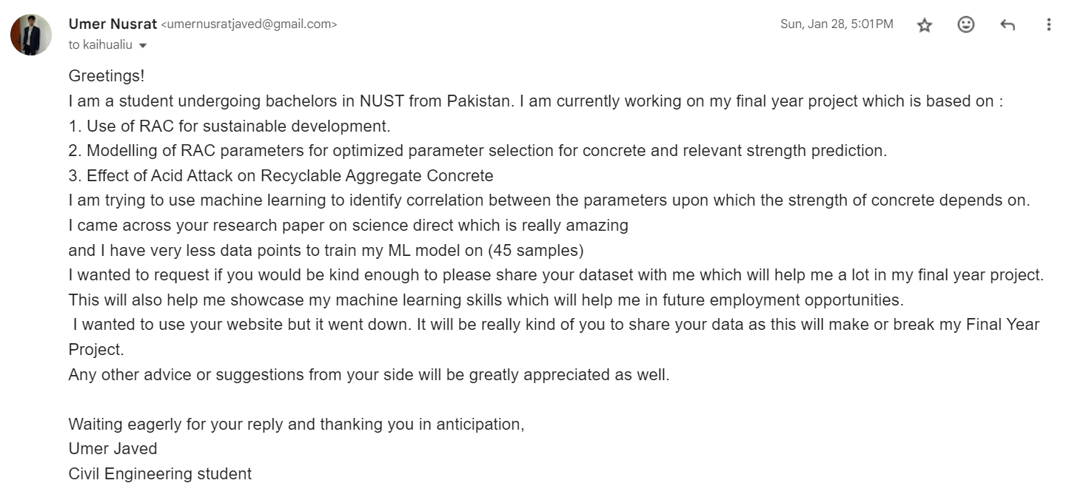

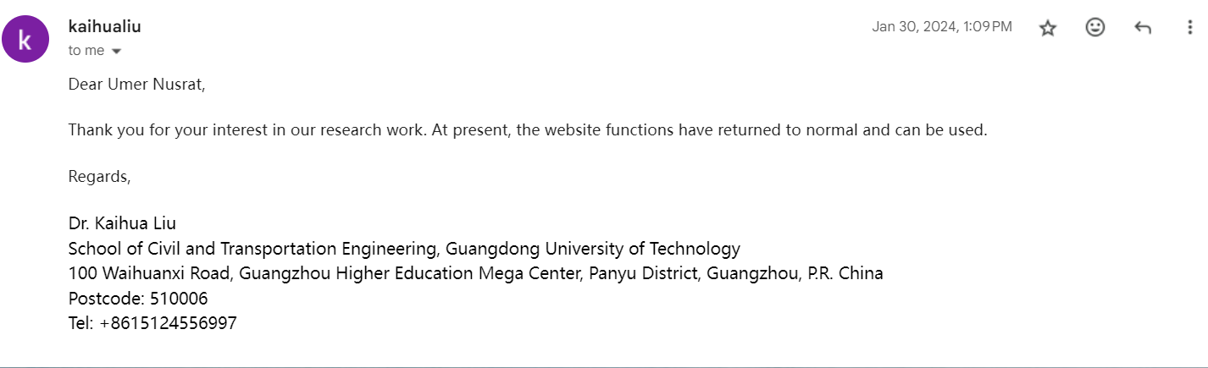

* + 1. **Data Preprocessing:** Performed initial data cleaning to remove duplicates, outliers, and irrelevant features, ensuring data quality.
    2. **Model Selection:** Evaluated eight models including decision trees, random forest, AdaBoost, etc., to determine the most suitable for predictive analytics.
    3. **Hyperparameter Tuning:** Employed grid cross-validation (CV) and Bayesian optimization techniques to fine-tune model hyperparameters for improved performance.
    4. **Feature Selection:** Utilized correlation matrices and pair plots to identify important features and mitigate multicollinearity, enhancing model interpretability.
    5. **Model Evaluation:** Employed standard metrics such as **R^2 (goodness of fit)**, **RMSE (root mean square error)**, **MSE (mean squared error)**, and **MAE (mean absolute error)** to assess model accuracy and generalization performance.
  1. **Application Development**
     1. **User Interface Design:** Developed a user-friendly application using pyQT5, enabling civil engineers to input data, make predictions, and visualize results conveniently.
     2. **Design & Theming:** Application was stylized keeping in view Material User Interface which is used in web applications.
     3. **Functionality Mapping:** Input fields were created to take input from user and apply necessary transformations to be used as input in the machine learning models.
     4. **Model Deployment:** Exported trained models in pickle format for seamless integration into the developed application, ensuring accessibility and usability.
  2. **Structural Defect Detection** Leveraged YOLO v8 CNN architecture with the Ultralytics framework to train a model for detecting cracks in concrete structures.
  3. **Data Augmentation** Augmented the crack detection dataset with variations in orientation and brightness to enhance model robustness and performance.
  4. **Validation** Validated predictive analytics results through extensive concrete casting experiments in the lab and cross-referenced crack detection with real-world data from the Roboflow Image Repository.

1. https://www.ncbi.nlm.nih.gov/pmc/articles/PMC9025364/
2. https://www.sciencedirect.com/science/article/pii/S2214509523001833
3. https://archive.ics.uci.edu/dataset/165/concrete+compressive+strength